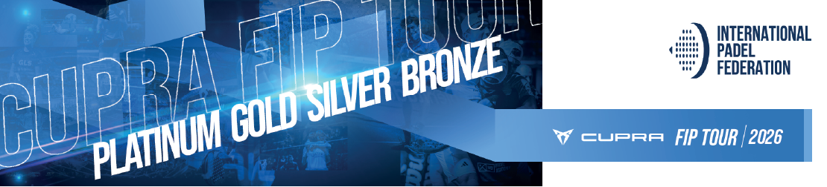

CUPRA FIP TOUR TOURNAMENT FACT SHEET
Please fill in all the information shown in blue

WEBSITE OVERVIEW
City / Country: XXXX / XXXX
Tournament category: BRONZE – SILVER – GOLD - PLATINUM
Promotional Tournament Name: XXXX
Name of the Club / Venue: XXXX
Address: XXXX
Website: XXXXX
Support Club / Venue: XXXX
Number of Match Courts: XXXX
Number of Practice Courts: XXXX
Court conditions: Outdoor / Covered / Indoor (height / meters)
Number of courts with outside game: 0-1-2-3-4…
Color of the turf: Blue / Black / Green….
Floodlights on the courts: Yes / No
Warm up Area / Gym: Yes / No
Restrooms: Yes / No
Players’ Lounge: Yes / No
Cafeteria / Restaurant: Yes / No
Balls: Bullpadel

* Please attach a short video or a set of photos showing the competition courts and the main player areas of the venue (e.g. warm-up zone, gym, rest area, locker rooms, food area). Send the material to josemaria.inigo@padelfip.com with copy to javier.lucia@padelfip.com.

TOURNAMENT DATES
Starting Date of Qualification: XX/XX/2026
Starting Date of Main Draw: XX/XX/2026
Date Finals: XX/XX/2026
Time Schedule SF and Finals: XX:XXh (local time)

REGISTRATION DEADLINE
Deadline registration: Friday2 weeks before the tournament starts XX/XX/2026 17:00h (CET)
* Any queries regarding player registration should be directed to registration@padelfip.com
* WC’s should be sent to competition@padelfip.com (One week before the beginning of the tournament)

DRAW SIZE
Main draw: 32 (26 DA + 4 Qualy + 2 WC)
Qualification draw: 32 (30 DA + 2 WC)
Qualification draw: 64 (56 DA + 8 WC)

MATCH SCHEDULE PLAN

* Please select the best option of MSP according to the courts and days of competition and the preferred size of the qualification’s draw. The promoter may propose a different MSP to the FIP than the ones stipulated, but it must be approved first by our competition department (competition@padelfip.com).

MSP OPTIONS for BRONZE, SILVER & GOLD with Qualy of 32 pairs

OPTION A
• Wednesday - 1st round qualification.
• Thursday - 2nd and 3th round qualification.
• Friday - 1st round MD.
• Saturday - 2nd round and QF MD.
• Sunday - SF and Finals MD.
OPTION B (More than 8 courts)
• Wednesday - 1st round qualification.
• Thursday - 2nd and 3th round qualification.
• Friday - 1st round MD and 2nd round
• Saturday - QF and Semifinals MD.
• Sunday - Finals MD.
OPTION C (More than 8 courts)
• Thursday - 1st and 2nd round qualification.
• Friday - 3rd round qualification and 1st round MD.
• Saturday - 2nd round and QF MD.
• Sunday - SF and Finals MD.

OPTION D (The only possible MSP option with 3 match courts)
• Tuesday (and Monday if needed) - 1st round qualification.
• Wednesday - 2nd and 3rd round qualification.
• Thursday - 1st round MD.
• Friday - 1st round MD.
• Saturday - 2nd round and QF MD.
• Sunday - SF and Finals MD.

MSP OPTIONS for BRONZE, SILVER & GOLD with Qualy of 64 pairs

OPTION A (8 courts or less)
• Tuesday (and Monday if needed) - 1st round.
• Wednesday - 2nd round.
• Thursday - 3rd and 4th round.
• Friday – 1st round Main Draw.
• Saturday – 2nd round and QF Main Draw.
• Sunday – SF and Finals Main Draw.
OPTION B (More than 8 courts)
• Wednesday - 1st round.
• Thursday - 2nd and 3rd round.
• Friday - 4th round Qualy and 1st round MD.
• Saturday – 2nd round and QF Main Draw.
• Sunday – SF and Finals Main Draw.

OPTION C (Only if MD starts before Friday)
• Tuesday (and Monday if needed) - 1st round Qualy.
• Wednesday - 2nd and 3rd round Qualy.
• Thursday - 4th round qualy and 1st round Main Draw.
• Friday - 2nd round Main Draw
• Saturday – QF and SF Main Draw.
• Sunday – Finals Main draw.

PLAYER FEE
Sign Up Fee: Fee € per player
*Max. 40€, to be paid at the venue

PRIZE MONEY
Payment method: Cash on Site / Bank Transfer
Contact e-mail / Tel. Number:
Total amount (€): XXXX € Promoter’s choice according to the tournament’s category
(Always 50% male / 50% female)
Withholding tax information: % deductions / promoter’s details

TOURNAMENT CONTACTS
*It is not allowed to be part of the tournament organizing team and compete as a player / coach in the same event.
*The Tournament Director acknowledges and agrees to be fully aware of the rules and guidelines set forth in the CFT Rulebook and the Promoter’s Manual.

Tournament Director
Name: XXXX
Phone: XXXX
Email: XXXX

Tournament Main Referee
Name: XXXX
Email: XXXX
Phone: XXXX

Player’s Desk
Name: XXXX
Email: XXXX
Phone: XXXX

Ball Delivery
Address: XXXX
Person in charge’s Name: XXXX
Contact number: XXXX
Email: XXXX

BRANDING GUIDELINES:

*To receive the graphic material please write an email to operations@padelfip.com.
*Any questions regarding the live scoring and streaming please contact: nicolas.cruz@padelfip.com.
*We kindly remind you that you do not have to produce anything in advance and that you must adhere to our guidelines present in the CFT Visual Identity guidelines that will be sent to you. In the meantime, we ask you to provide us below the contact information of those in charge of photos and streaming:

Responsible for content and photos:
Name: XXXX
WhatsApp Number: XXXX
Email: XXXX

Responsible for live scoring / streaming:
Name: XXXX
WhatsApp Number: XXXX
Email: XXXX

PLAYER SERVICES

Official Hotel Information
Hotel’s Name: XXXX
Number of Stars: XXXX
Address: XXXX
Distance to the venue: XXXX
Hotel Contact Details: XXXX
Special rates: single room
Special rates: double room
Additional info: link / discount code

Transportation Services
Nearest Airport Name: XXXX
Distance to the venue: XXXX
Nearest Train Station Name: XXXX
Distance to the venue: XXXX

Airport pick up: YES / NO (free of charge or special rate)
Daily Hotel - Club service: YES / NO
Transportation Service Contact Email / Tel. Nº: XXXX

Practice courts
Available dates / timetables: XXXX
Booking Protocol: XXXX
Contact Email / Tel. Nº: XXXX
Free of charge: YES / NO

Medical Services
Medical plan: XXXX
Number of Physiotherapist: XXXX
Name of the Responsible Physiotherapist: XXXX
Physiotherapist’s Telephone: XXXX
Physiotherapist’s Email: XXXX
Doctor’s Name: XXXX
Doctor’s Telephone: XXXX

OTHER INFORMATION
Police Station: XXXX
Emergencies: XXXX
Nearest hospital: XXXX
Visa Requirements: XXXX

*For any questions regarding player services, please contact javier.lucia@padelfip.com.



